# Developer Guide

**JWebSocket**

**jWebSocket Long-Polling fallback.**

**Name, Date, Author, History missing ?**

# Overview

Currently if the users have older browsers and no flash support their client application cannot connect to the jWebSocket server. The goal of this project is resolve this problem using XHR/long-polling fallback as transport when we do not have websocket or flash support. This solution is also required to circumvent older Proxies which do not yet allow to pass through web socket packets, this is a very important argument, which should be explained a bit here!

1. **Infrastructure, Model, Approach**

The solution has two mains packages that are integrated in to the client and server of jWebSocket framework. The package that is embed into jWebSocket client is called websocketXHR (renamed to jWebSocketComet.js!) and it is a websocket implementation using XHR-Long-Polling as transport. In the server side the package has the org.jwebsocket.comet namespace and inside it are the CometEngine,CometConnector and the CometServlet to handler the XHR/AJAX request from the client. In the diagram below this approach is showed.

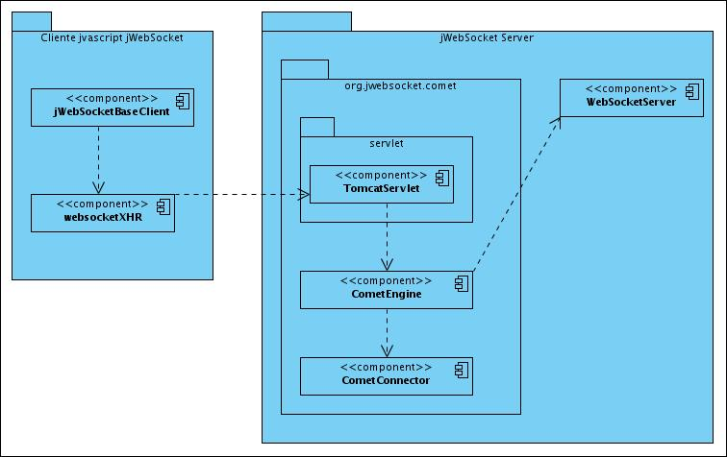

The servlet is used to receive the request from the client and has a great importance in the development of the solution. This servlet implement the org.apache.catalina.comet.CometProcessor interface provided by Apache Tomcat to handler advance XHR/AJAX request, where the life cycle of each request passes through a series of events that give facilities to implement the long-polling technique. Using the event we can receive, read, write, hold and close each request from the client side, to get more information about CometProcessor please refers to http://tomcat.apache.org/tomcat-7.0-doc/aio.html. CometProcessor is implemented based on NIO, since this provides a great number of features to handle input and output asynchronously requests that are not supported by the standard used by Tomcat connector (HTTP / AJP). The first prerequisite to run this solution must be replace in the Tomcat configuration file the HTTP / AJP Connector set by default with the NIO connector. This could be done in the server.xml file shown in the example below.

<!-- Connector port="8080" protocol="HTTP/1.1"

connectionTimeout="20000"

URIEncoding="UTF-8"

redirectPort="8443" / -->

<Connector connectionTimeout="20000" port="8080"

protocol="org.apache.coyote.http11.Http11NioProtocol"

redirectPort="8443"/>

Here we also need to explain how the NIO engine can be used in an embedded environment, like in jWebSocket.

The above configuration is the only one that is mandatory but is still recommended increase the minimum size of RAM memory available for Tomcat altering the min values ​​for catalina.Xms(Minimum memory available to tomcat) and Xmx (maximum memory which can have tomcat).

In linux you could do this as follows.

export CATALINA_OPTS="-Xms512m -Xmx1024m"

In Windows:

set CATALINA_OPTS=%CATALINA_OPTS% -Xms512m -Xmx1024

You can get the same result by increasing the maximum memory size that can use the Java virtual machine, but in our case is much more advisable just increase the memory available for Tomcat.

# Modules, Structures

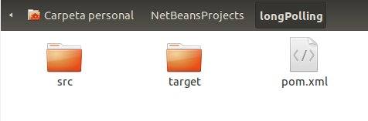

**src:**  All java.classes uses in the solution and a sample application. There is also a folder named "webapp" that contains a sample web application that uses the library XHRWebsocket to test the long-polling solution.

**target:** This directory stores the compiled source, also includes longPolling file-1.0.war with which you can deploy the sample application quickly and easily in tomcat server.

**pom.xml:** Configuration file which specifies the characteristics and dependencies of the project maven.

**General Units:**

org.jwebsocket.comet package depends of several jWebSocket libraries, therefore we need to add org.jwebsocket dependencies. The other dependency is about CometProcessor that is inside org.apache.tomcat.embed package. Those Dependencies can be imported using maven as presented below.

1. </dependency>
2. <dependency>
3. <groupId>org.jwebsocket</groupId>
4. <artifactId>jWebSocketServer</artifactId>
5. <version>1.0</version>
6. </dependency>
7. <dependency>
8. <groupId>org.apache.tomcat.embed</groupId>
9. <artifactId>tomcat-embed-core</artifactId>
10. <version>7.0.21</version>
11. </dependency>
12. </dependencies>

These dependencies are required when running stand-alone i.e. out of NetBeans:

<dependency>

<groupId>org.apache.tomcat.embed</groupId>

<artifactId>tomcat-embed-core</artifactId>

<version>${org.apache.tomcat.version}</version>

</dependency>

<dependency>

<groupId>org.apache.tomcat.embed</groupId>

<artifactId>tomcat-embed-logging-juli</artifactId>

<version>${org.apache.tomcat.version}</version>

</dependency>

<dependency>

<groupId>org.apache.tomcat.embed</groupId>

<artifactId>tomcat-embed-logging-log4j</artifactId>

<version>${org.apache.tomcat.version}</version>

</dependency>

<dependency>

<groupId>org.apache.tomcat.embed</groupId>

<artifactId>tomcat-embed-jasper</artifactId>

<version>${org.apache.tomcat.version}</version>

</dependency>

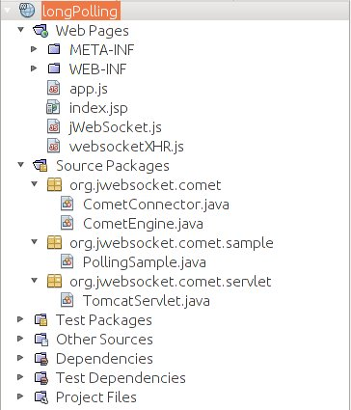

# Source Code

The solution integrates components on the client and server of jWebSocket framework. In the server side all the solution is embed in org.jwebsocket.comet package. In the client side the solution is just the XHRWebSocket component.

|  |  |
| --- | --- |
| **Package: org.jweboscket.comet** | |
| **Component** | **org.jweboscket.comet.CometEngine** |
| **Description** | It is an implementation of jWebSocket Engine. This class extends of base Engine, and overwrites some functionality to adjust to the long-polling solution. |
| **Class** | CometEngine |
| **Class CometEngine** | |
| **Extends** | BaseEngine |
| **Dependencies** | import java.util.Map;  import java.util.Queue;  import java.util.concurrent.ConcurrentLinkedQueue;  import javolution.util.FastMap;  import org.jwebsocket.api.EngineConfiguration;  import org.jwebsocket.api.WebSocketConnector;  import org.jwebsocket.comet.servlet.TomcatServlet;  import org.jwebsocket.engines.BaseEngine;  import org.jwebsocket.kit.CloseReason;  import org.jwebsocket.kit.WebSocketException;  import org.apache.log4j.Logger;  import org.jwebsocket.api.WebSocketPacket;  import org.jwebsocket.logging.Logging; |
| **Package: org.jweboscket.comet** | |
| **Component** | **org.jweboscket.comet.CometConnector** |
| **Description** | It is the connector to uses with this solution. |
| **Class** | CometConnector |
| **Class CometConnector** | |
| **Extends** | BaseConnector |
| **Dependencies** | import java.io.IOException;  import java.io.PrintWriter;  import java.net.InetAddress;  import java.net.UnknownHostException;  import java.util.Map;  import javolution.util.FastMap;  import org.apache.catalina.comet.CometEvent;  import org.jwebsocket.api.WebSocketEngine;  import org.jwebsocket.connectors.BaseConnector;  import org.jwebsocket.kit.CloseReason;  import org.apache.log4j.Logger;  import org.jwebsocket.api.WebSocketPacket;  import org.jwebsocket.comet.servlet.TomcatServlet;  import org.jwebsocket.kit.RawPacket;  import org.jwebsocket.logging.Logging;  import org.jwebsocket.packetProcessors.JSONProcessor; |
| **Package: org.jweboscket.comet.servlet** | |
| **Component** | **org.jweboscket.comet.servlet.****TomcatServlet** |
| **Description** | This component is used to handle incoming HTTP requests, to implement the long-polling technique, and the communication with the CometEngine component. |
| **Class** | TomcatServlet |
| **Class** TomcatServlet | |
| **Extends** | **HttpServlet** |
| **Implements** | **CometProcessor** |
| **Dependencies** | **java.io.IOException;**  **java.io.InputStream;**  **java.io.PrintWriter;**  **java.util.Map;**  **javax.servlet.ServletException;**  **javax.servlet.http.HttpServlet;**  **javolution.util.FastMap;**  **org.apache.catalina.comet.CometEvent;**  **org.apache.catalina.comet.CometEvent.EventType;**  **org.apache.catalina.comet.CometProcessor;**  **org.jwebsocket.comet.CometConnector;**  **org.jwebsocket.comet.CometEngine;**  **org.jwebsocket.factory.JWebSocketFactory;**  **org.jwebsocket.kit.RawPacket;**  **org.apache.log4j.Logger;**  **org.json.JSONObject;**  **org.jwebsocket.api.WebSocketConnector;**  **org.jwebsocket.kit.CloseReason;**  **org.jwebsocket.kit.RequestHeader;**  **org.jwebsocket.logging.Logging;**  **org.jwebsocket.packetProcessors.JSONProcessor;** |

**Client:** The XHRWebSocket component is embedded within the native jWebSocket JavaScript client and aims to be used automatically in the absence of WebSocket or flash suport.

|  |  |
| --- | --- |
| **Package: XHRWebSocket** | |
| **Component** | **XHRWebSocket** |
| **Description** | XHRWebSocket is an object that emulates the usual behavior of the object WebSocket. It uses long-polling to emulate a keep alive connection with several request, send and receive data at the same time. |

**Libraries and tools used:**

* Tomcat CometProccesor.
* Servidor Apache Tomcat 7,0
* NetBeans 7.0.1
* Maven
* jWebSocket framework

I would like to see automation: If no native websockets are available and not flash as well, we automatically should use Comet. The server per default can run two engines at a time!

**Highlights for developers:**

To implement the XHRWebSocket component was necessary think in how to deal with the two HTTP connection limit issue. The limit of only two connections per server means that if you have two connections open and starts a third or several N requests, the N requests will be locked until one of the two previous requests finish. In this case to simulate the keep-alive connection to the server and receive instant messages in the moment that are available on the server side, the XHRWebSocket component keeps busy one of the two connections. So in order to send a simple message to the server with the word "Hello", the client must use another HTTP request, even when this second request is not delayed by the server, in the moment in which the server takes the message the two limit connections are busy. If the client tries to send one or more messages at this time all those HTTP requests will be blocked. Once the request used to send the word “Hello” is deliberate, the blocked messages could be send in no particular order and in the worst case the server for security reasons could destroy our session.

To solve the problem mentioned in the previous paragraph was implemented a message queue in the XHRWebSocket component. As mentioned above to simulate the connection and receive messages from the server one request is always busy, so we only have one channel to send. This request that is used to send messages to the server is never delayed by the server. The server receives the request with the message and checks if there is a message available for this client, if so this puts the message in response to the request and immediately release the request to the client, if there is no messages the request is release in the same way, enabling again the connection to send data at any time. But if the user try to send a message when the request used to send message is busy, the message is store in to the queue and always that the request is release by the server in the client side the queue is checked and the pending messages are sending.

The connection used to simulate the keep-alive connection also has the purpose of bringing messages from the server. The component uses long-polling technique to keep one of the two possible open requests to the server. When the server has a message to send to the client it put the message in the request response. Once this response arrived to the client the onMessage event is fired with the message, and the XHRWebsocket component re-launches the request in order to emulate the keep-alive connection gains.